1.
#include <stdio.h>
#include <string.h>

int main() {
char str[100];

printf("Enter the string: ");
scanf("%s", str);

int len = strlen(str);

if (len > 0 && str[0] == 'a' && str[len - 1] == 'a')
printf("String Accepted\n");
else
printf("String Rejected\n");

return 0;
}
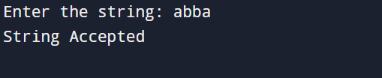
2.
#include <stdio.h>
#include <string.h>

int main() {
char str[100];

printf("Enter the string: ");
scanf("%s", str);

int len = strlen(str);

if (len > 0 && str[0] == '0' && str[len - 1] == '1')
printf("String Accepted\n");
else
printf("String Rejected\n");

return 0;
}
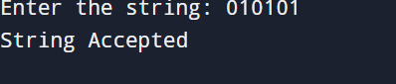
3.
#include <stdio.h>
#include <string.h>

int main() {
char str[100];
int len;

printf("Enter the string: ");
scanf("%s", str);

len = strlen(str);

if (len >= 2 && str[0] == '0' && str[len - 1] == '1')
printf("String Accepted\n");
else
printf("String Rejected\n");

return 0;
}
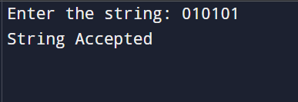
4.
#include <stdio.h>
#include <string.h>

int main() {
char str[100];
int i, len, flag = 1;

printf("Enter the string: ");
scanf("%s", str);

len = strlen(str);

for (i = 0; i < len / 2; i++) {
if (str[i] != str[len - i - 1]) {
flag = 0;
break;
}
}

if (flag)
printf("String Accepted\n");
else
printf("String Rejected\n");

return 0;
}
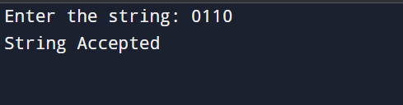
5.
#include <stdio.h>
#include <string.h>

int main() {
char str[100];
int len, i = 0, j, left0 = 0, right0 = 0;

printf("Enter the string: ");
scanf("%s", str);

len = strlen(str);

while (i < len && str[i] == '0') {
left0++;
i++;
}

j = len - 1;
while (j >= 0 && str[j] == '0') {
right0++;
j--;
}

if (left0 != right0) {
printf("String Rejected\n");
return 0;
}

for (i = left0; i <= j; i++) {
if (str[i] != '1') {
printf("String Rejected\n");
return 0;
}
}

printf("String Accepted\n");
return 0;
}
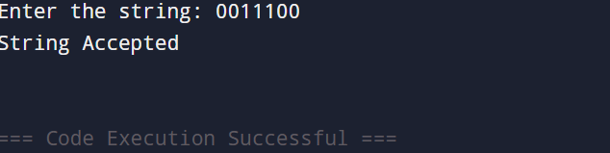
6.
#include <stdio.h>
#include <string.h>

int main() {
char str[100];
int len, i, zeros = 0, ones = 0;

printf("Enter the string: ");
scanf("%s", str);

len = strlen(str);

i = 0;
while (i < len && str[i] == '0') {
zeros++;
i++;
}

while (i < len && str[i] == '1') {
ones++;
i++;
}

if (i == len && zeros == ones)
printf("String Accepted\n");
else
printf("String Rejected\n");

return 0;
}
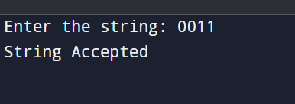
7.
#include <stdio.h>
#include <string.h>

int main() {
char str[100];

printf("Enter the string: ");
scanf("%s", str);

if (strstr(str, "101") != NULL)
printf("String Accepted\n");
else
printf("String Rejected\n");

return 0;
}
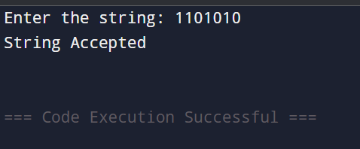

8.
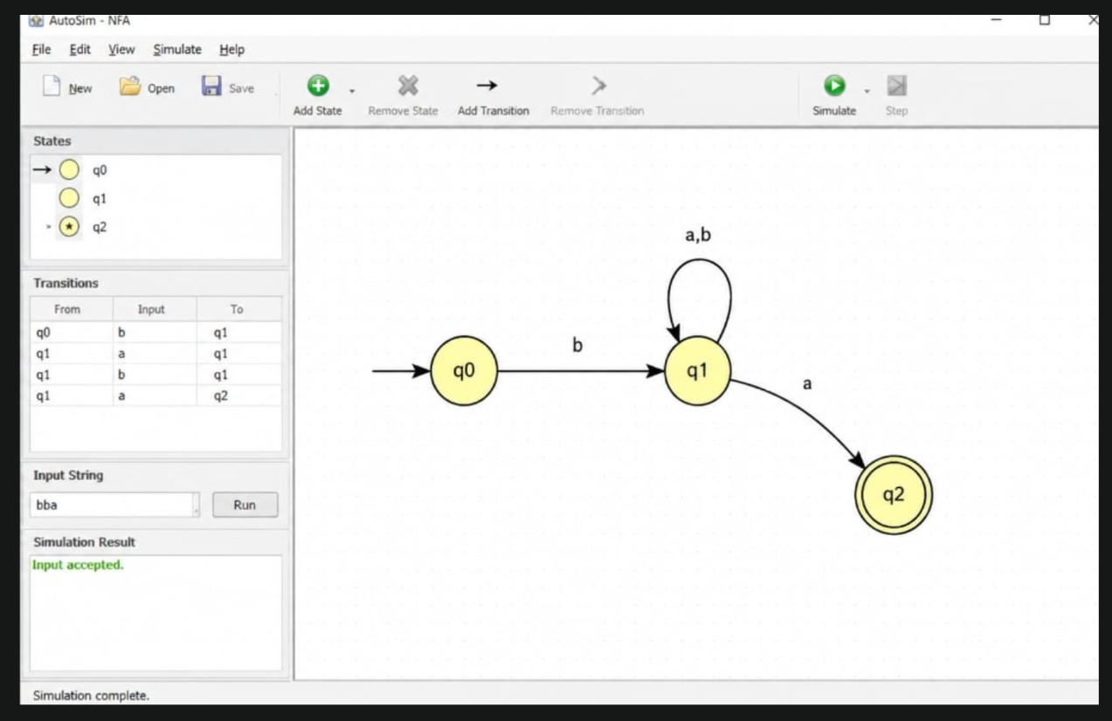

9.
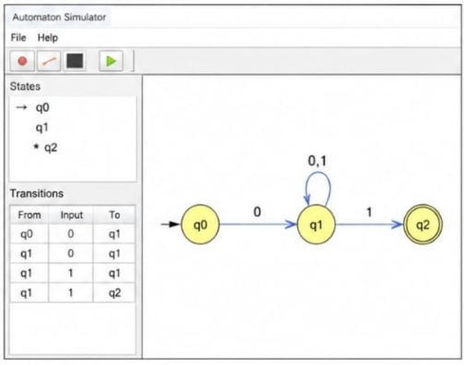

10.
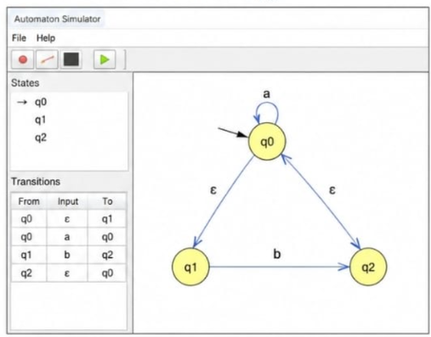

11.
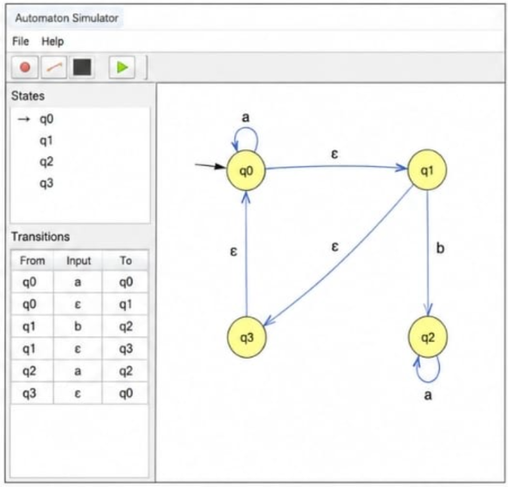
12.
